**DESIGN DOCUMENTATION**

**for HYPERMEDIA   
APPLICATIONS EXAM**

*Group members:*

Leonardo Panizzo, email: [leonardo.panizzo@mail.polimi.it](mailto:leonardo.panizzo@mail.polimi.it), cod. p.:

Nicholas Magatti, email: [nicholas.magatti@mail.polimi.it](mailto:nicholas.magatti@mail.polimi.it), cod. p.: 10493205

*Delivery date:*

5th September of 2019

*Prototype:*

[https://hypermdia-magatti-panizzo.herokuapp.com](https://hypermdia-magatti-panizzo.herokuapp.com/)

*INDEX*

**Introduction: pag 3**

**C-IDM: pag 3**

**L-IDM: pag 4**

**Design-in-the-small: pag 5**

**E-R Diagram (DB Design): pag //TODO**

**Relational Tables (DB Design): pag //TODO**

NOTE: as decided by prof. Garzotto, example of scenarios will not be requested from our group for this design report.

*INTRODUCTION*

This is the design documentation of the website of a festival of contemporary arts created for the purpose of the exam of Hypermedia Application at Politecnico di Milano.  
The website allows to register, get reservations for events and shows the list of the events (artistic events and seminars) and information about the artists who are performing during the festival.

*C-IDM*

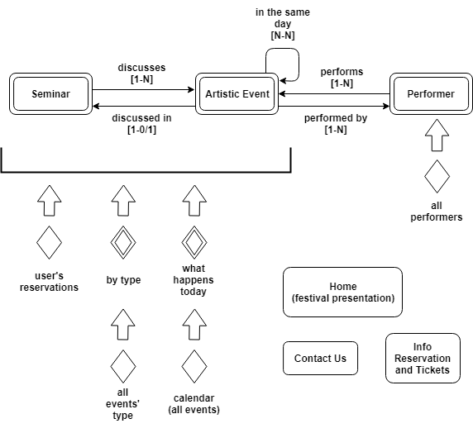

*L-IDM*

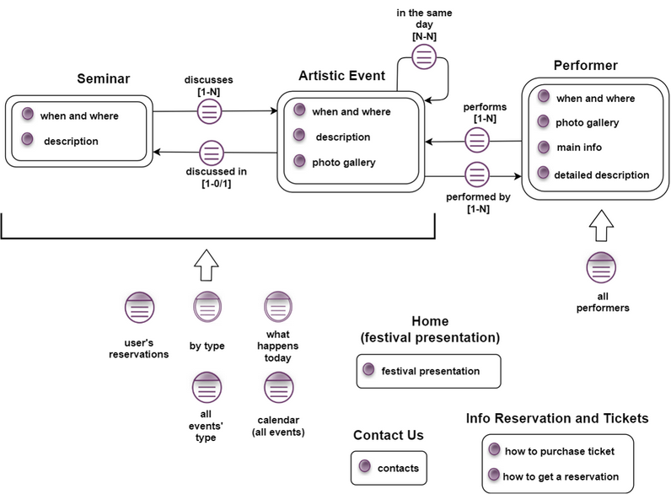

*DESIGN-IN-THE-SMALL*

The page design (P-IDM) will be presented in two forms: schematic view of the pages first(low fidelity wireframe), then commented screenshots.

*DATABASE DESIGN*

The database will be presented with its E-R diagram and relational tables, followed by explanatory comments.

***E-R DIAGRAM***

***RELATIONAL TABLES***